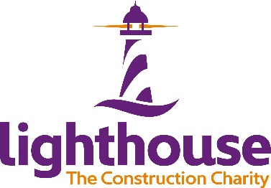

The Lighthouse Charity

The Lighthouse Charity provides 24/7 holistic support to our UK and Ireland construction community on all aspects of emotional, physical and financial wellbeing.

A crucial element of the charity’s strategy is to provide a range of free and widely available reactive and proactive resources to support the industry.
They offer a free and confidential 24/7 helpline, live web chat service and text facility which provides a range of information, guidance and support on a huge variety of wellbeing issues. These services are complemented by their free self-support app, along with their Lighthouse Beacons who provide a safe space for people to share concerns.
The charity’s Wellbeing Academy offers a variety of free soft skills and leadership training delivered across a variety of platforms to suit every learning style.

If you or anyone you know is struggling, reach out for 24/7 free and confidential support now;
24/7 helplines; 0345 605 1956, (UK) 1800 939 122 (ROI)
Live chat www.lighthousecharity.org
Text HARDHAT to 85258
Find out more at www.lighthousecharity.org

How to reference our charity
In the first instance in any copy, please refer to us as the Lighthouse Charity. From thereon you can continue to use the Lighthouse Charity or simply refer to us as ‘Lighthouse’.
Logos in all formats can be found here

